**Hypothesis Testing**

S. Mahesh Anand

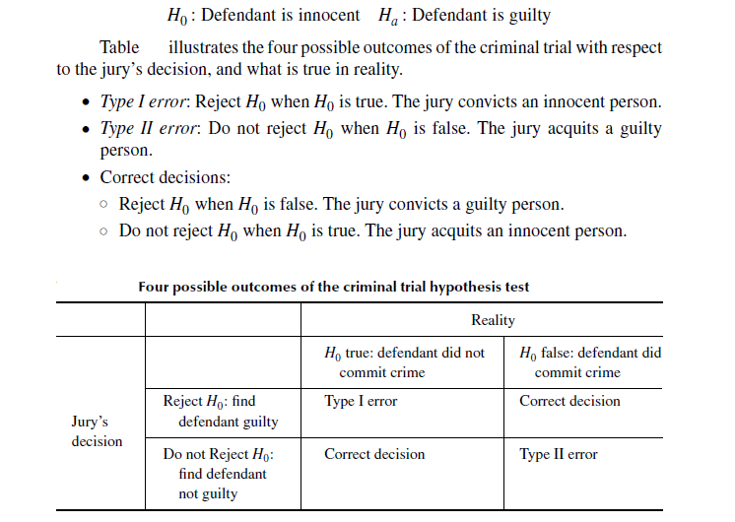

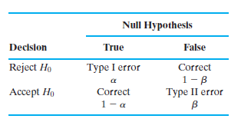

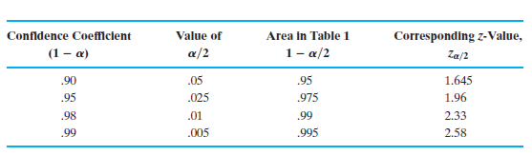

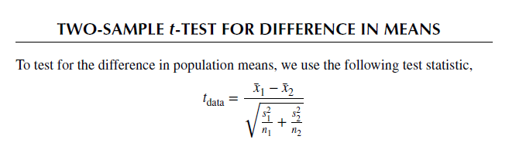

**TWO-SAMPLE Z-TEST FOR DIFFERENCE IN PROPORTIONS**

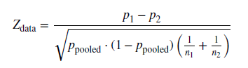

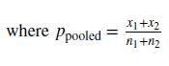

**CHI-SQUARE TEST FOR GOODNESS OF FIT OF MULTINOMIAL DATA**

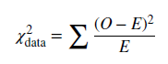



Example Data (observed count)

Healthy Mild severe Total

Sample-1: 410 340 250 1000

Sample-1: 95 85 70 250

Total: 505 425 320 1250

Expected Frequencies

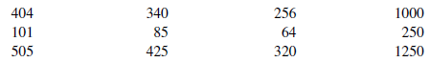

**ANALYSIS OF VARIANCE (ANOVA F-Test)**

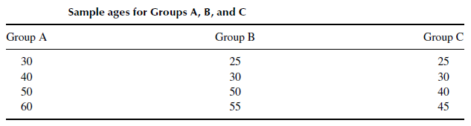

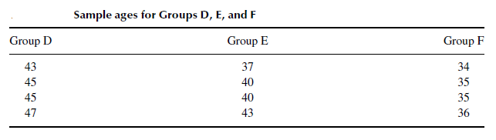

**Between sample variability:** Finding the variance of K-sample means, weighted by sample size and expressed as **Mean Square Treatment (MSTR)**

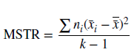

Where ni is number of samples in each group (here 4 samples/per group)

Numerator of MSTR is the *sum of the squares treatment (SSTR) and* denominator term K-1 is the degrees of freedom.

**Within sample variability:** Finding the weighted mean of sample variances, expressed as **Mean Square Error (MSE)**





Numerator of MSE is the *sum of the squares error (SSE) and* denominator term nt-k is the degrees of freedom.

The total number of squares (SST) is the sum of SSTR + SSE. ANOVA table is the convenient way to display all these parameters.

